Downloading Anaconda:

Step 1:

Go to Google and type Anaconda Download

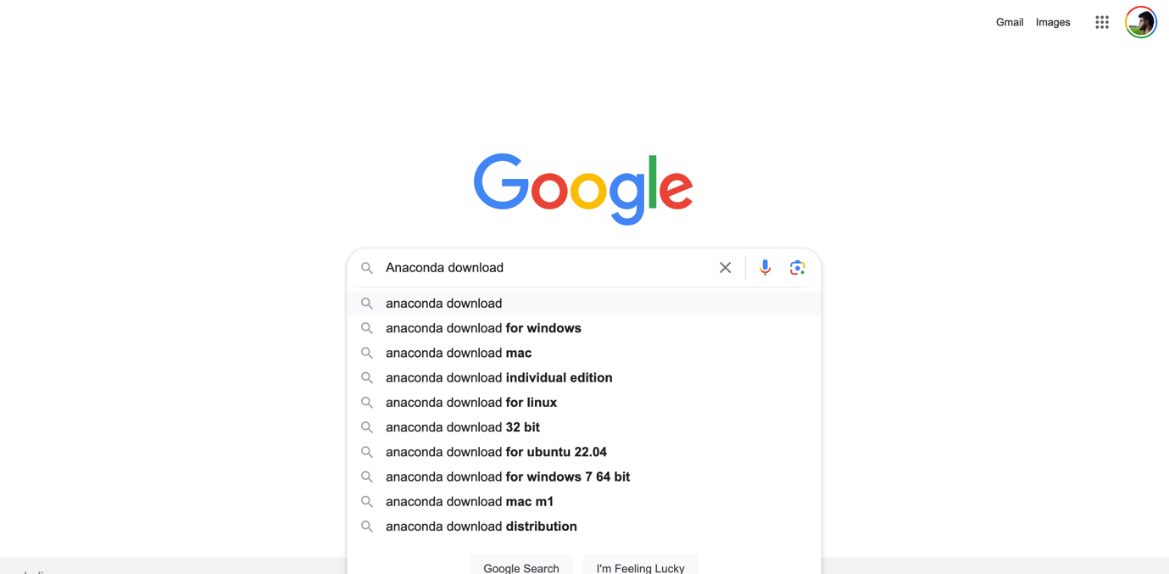

Step 2:



Step 3:

Please once you are in the <https://www.anaconda.com/download>

Please carefully select the version as per your system requirements:

[Intel / Mac M1 / M2 / 32-bit / 64-bit]

Check Link:

<https://support.microsoft.com/en-us/windows/32-bit-and-64-bit-windows-frequently-asked-questions-c6ca9541-8dce-4d48-0415-94a3faa2e13d>

<https://docs.cse.lehigh.edu/determine-mac-architecture/>



Step 4:

Once downloaded, Please Install

**FOR MAC USERS:**

For Mac users its pretty straight forward just install next steps as they go.

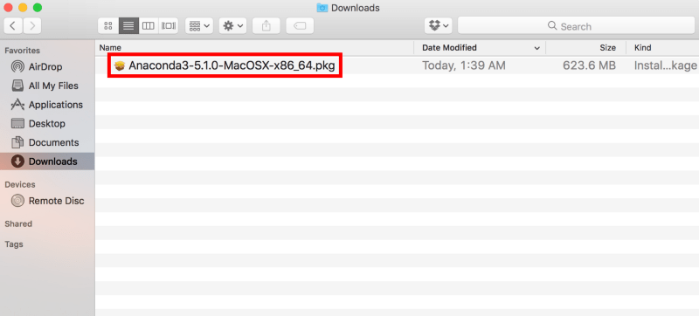

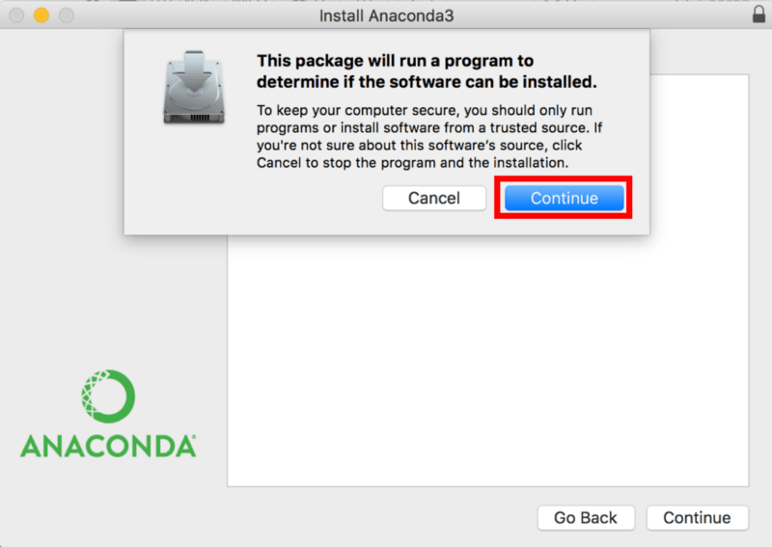

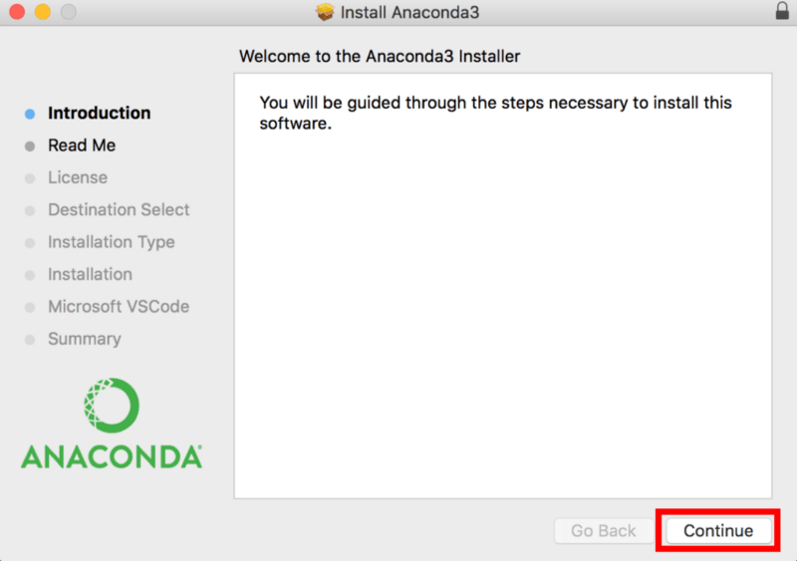

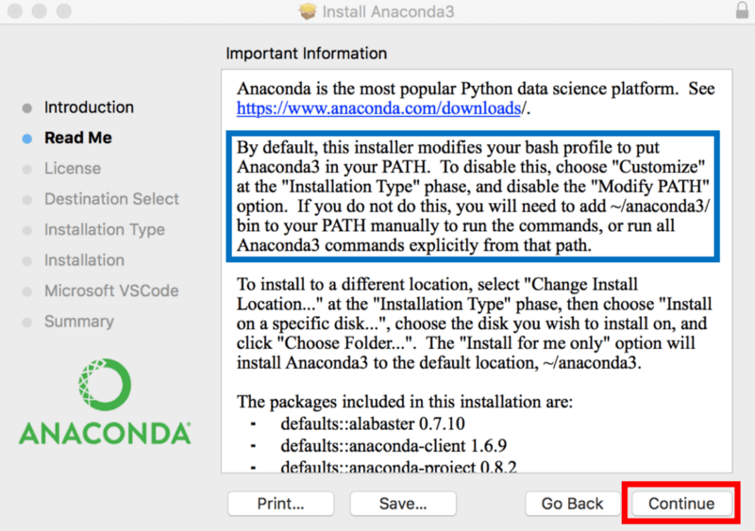

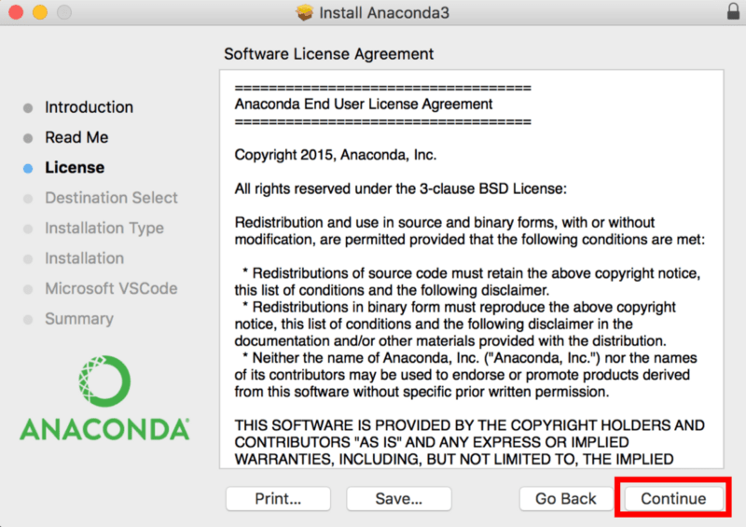

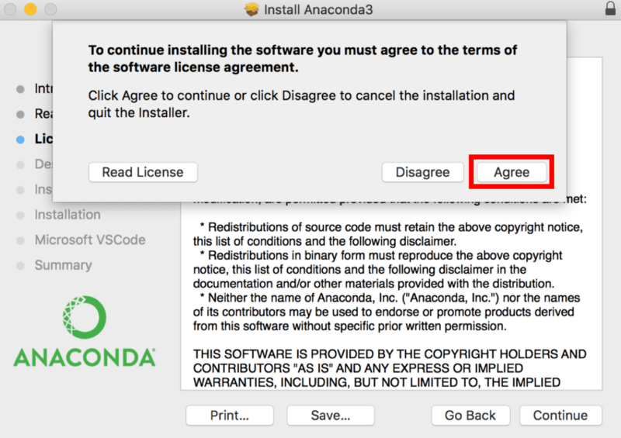

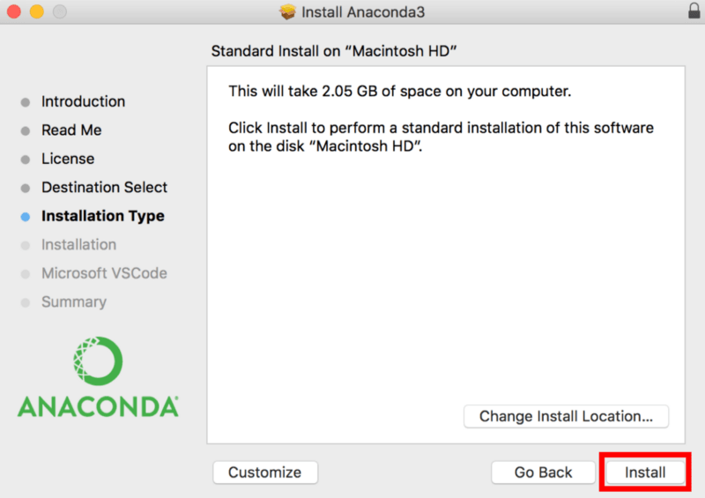

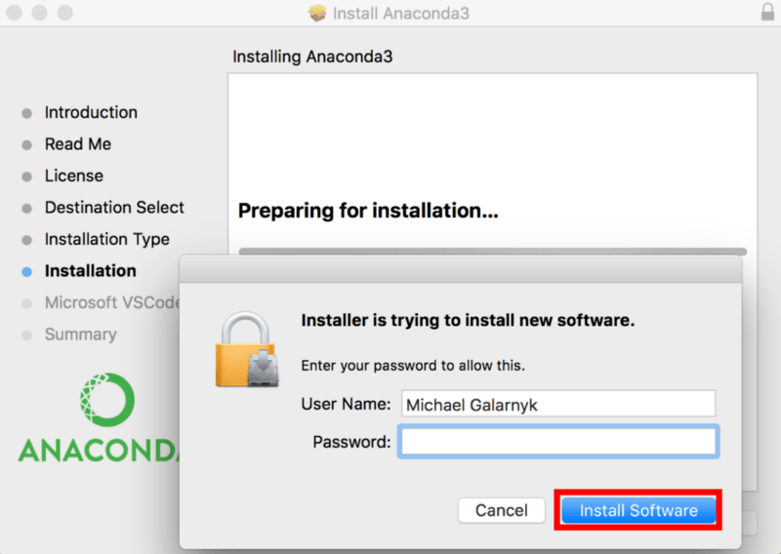

Click on Continue. You can install Microsoft Visual Studio Code. It is an Integrated Development Environment. You can learn about Python Integrated Development Environments [**here**](https://www.datacamp.com/tutorial/data-science-python-ide).

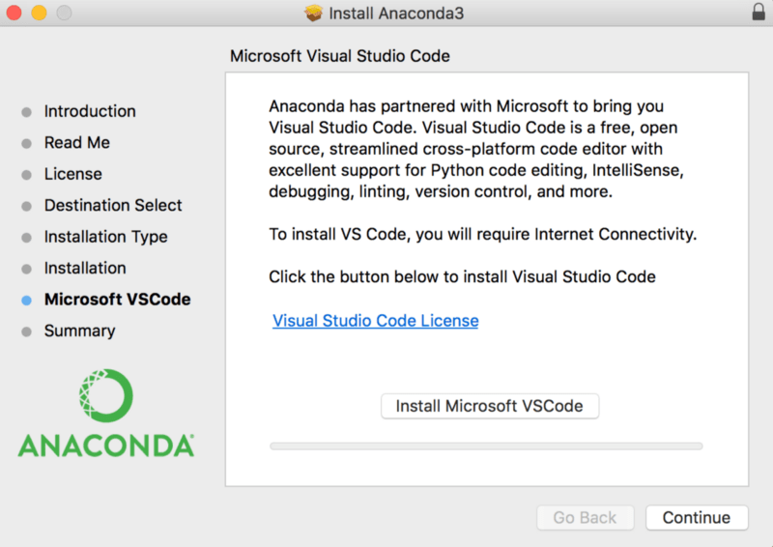

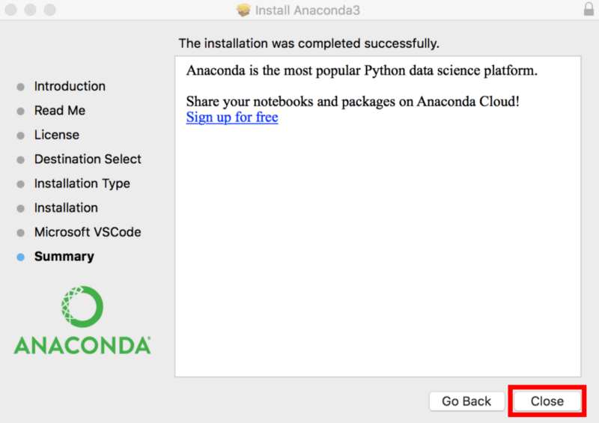

**Test your Installation**

1 - Open a **new terminal** on your Mac. You can do this by clicking on the Spotlight magnifying glass at the top right of the screen, type “terminal” then click on the terminal icon. Now, type the following command into your terminal

python --version



If you had chosen a Python 3 version of Anaconda (like the one in the image above), you will get an output similar to above.

output 1

If you had chosen a Python 2 version of Anaconda, you should get a similar output to the one below.

python --version

output 2

2 - Another good way to test your installation is to try and open a Jupyter Notebook. You can type the command below in your terminal to open a Jupyter Notebook. If the command fails, chances are that Anaconda isn’t in your path. See the next section on Common Issues.

jupyter notebook

OpenAI

The image below shows a Jupyter Notebook in action. Jupyter notebooks contain both code and rich text elements, such as figures, links, and equations. You can learn more about Jupyter Notebooks [**here**](https://www.datacamp.com/tutorial/tutorial-jupyter-notebook).

